* **Annotation**

@Id

@GeneratedValue(strategy, generator)

* **@Id**
  + Là field primary key (Identifiers)
  + Mỗi entity có 1 primary key
  + Primary key có thể 1 hoặc nhiều field
  + Datatype phải là Java primitive hoặc primitive wrapper types (String, Date, BigDecimal, BigInteger)

VD:

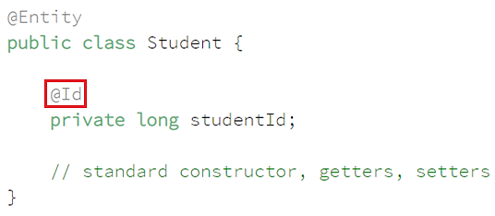

* **@GeneratedValue(strategy, generator)**

Có thể Override @Id bằng cách @GeneratedValue

* + **strategy**: ?
    - **GenerationType.TABLE**

Disadvantage: it doesn't scale well and can negatively affect performance.

VD: customize table

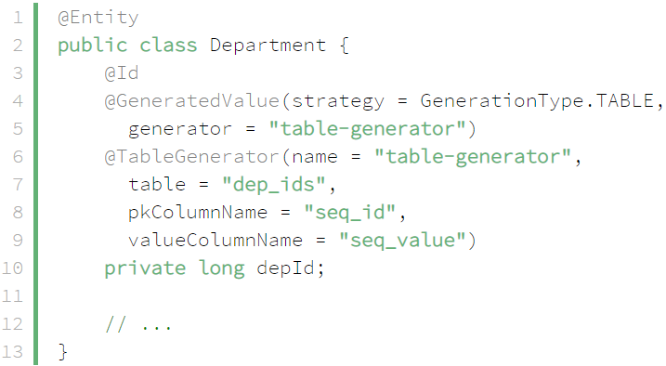

* + - **GenerationType. SEQUENCE**

Sử dụng SequenceStyleGenerator class

If you don't specify a sequence name, Hibernate will re-use the same hibernate_sequence for different types

VD: custom sequencce

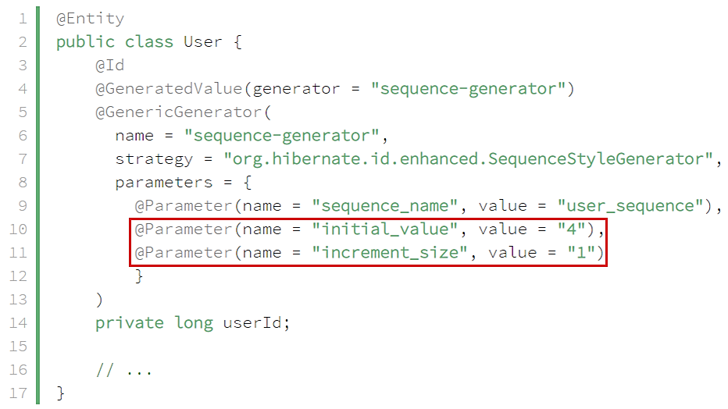

*primary key generation will start at 4 with step = 1*

* + - **GenerationType. IDENTITY**

id Primarykey tự động tăng

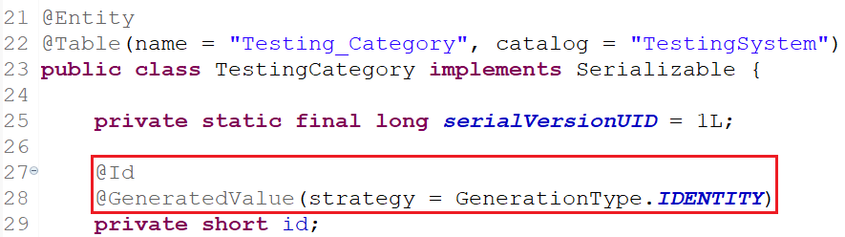

* + - **GenerationType. AUTO** (default)
      * Datatype có thể là number hoặc UUID
      * UUID sẽ sử dụng UUIDGenerator

VD:

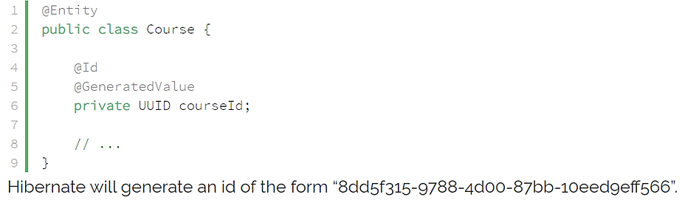

* **Custom Generator**

VD: identifiers containing a String prefix and a number:

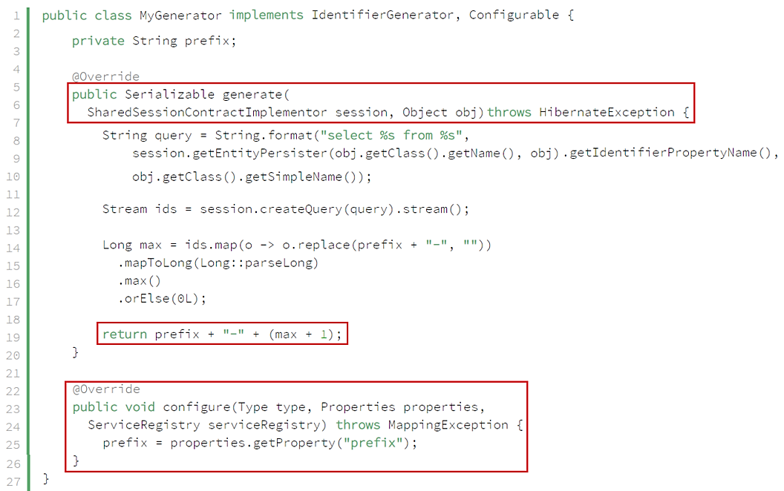

*first find the highest number from the existing primary keys of the form prefix-XX.*

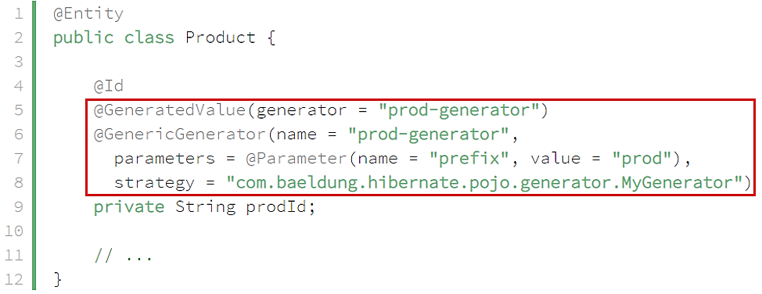

* **Reference**

<https://www.baeldung.com/hibernate-identifiers>